Demyanyk et al. (2008)

Demyanyk et al. (2008): “Risk sharing and portfolio allocation in EMU”, European Economy. Economic Papers, no. 334.

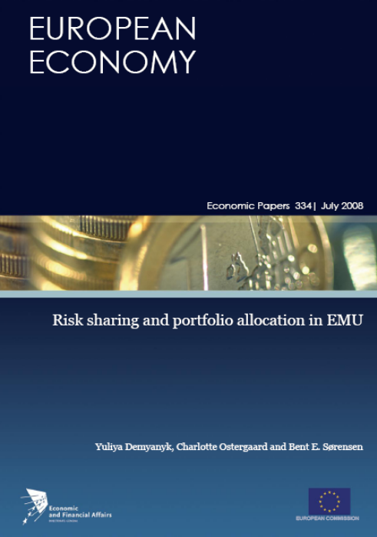

NB1: Authors have numerous related (and academically much stronger!) papers on the topic!
NB2: Only main points discussed here!
1. Introduction

O&R, ch. 5
→
If perfect integration of capital markets
⇒
Pooling of risks
⇒
Consumption (generally: resources available for individuals’ use) in a country is decoupled from production in the country, but closely connected to production in the “integration area” (the world in O&R)

Test of decoupling convenient test of (financial) integration
→
Decoupling in European countries after the 1990s euro integration?
- Run-up to euro 1995-1999
- After introduction of euro 2000-2006

Empirical analysis using simple methods!
2. Risk sharing: income smoothing and consumption smoothing

From O&R, ch. 1:

NB: GNI  GNP (used in O&R) ← main difference relates to treatment of taxes

GDP → resources produced in country
GNI → resources available for individuals in country

Difference between GNI and GDP → net factor income / return on net international investment position

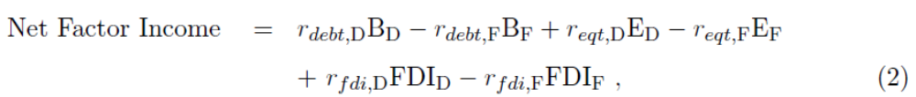

- B = Bonds, E = Equity, FDI = foreign direct investment
- Subscripts: _{D} = Domestic, _{F} = Foreign

NB: Potentially other components of net international investment position (cf. discussion of the international balance of payments in 2nd class)
International financial integration (here: introduction of euro)
⇒
When GDP fluctuates, does net factor income help smooth:
- GNI / income ~ resources available for domestic use?
- Consumption, C?

Does international financial integration ⇒ international risk sharing? 
3. Measuring risk sharing: Income smoothing and consumption smoothing

Individual country → subscript _{i}
Group of euro area / EU countries → no subscript

Sharing / smoothing of income

Country i euro area average / EU average

Cross-sectional estimations of constant term and 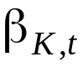 for each t

Perfect risk sharing of income ⇒ = 0

“Degree of risk sharing” of income = 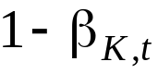

Perfect / complete risk sharing of income ⇒ = 1 = 100%
Sharing / smoothing of consumption

“Degree of risk sharing” of consumption = 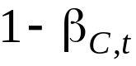

Results 

Cross-sectional estimations for each t (smoothed over years)
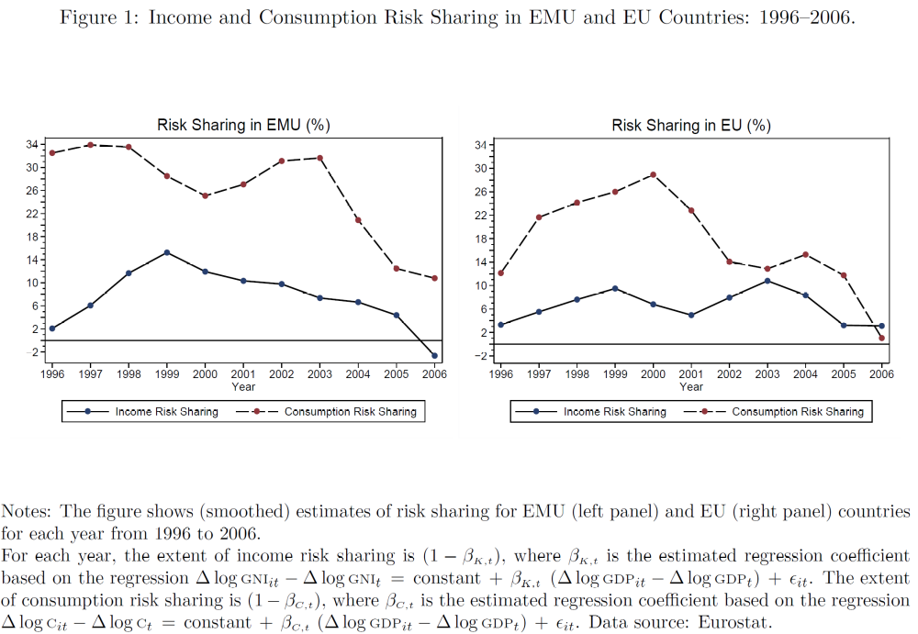
euro area
3.3 Panel data regressions: Specification

Panel data → assume effect constant over time

Country fixed effect

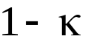 = average (over time and across countries) risk sharing
- Perfect risk sharing if = 1 = 100%

NB: Estimate panel for two sub-periods (before / after euro integration): 1995-1999, 2000-2006

Why panel?
- More observations, more precise estimations
- Later extend model with direct measures of foreign financial holdings

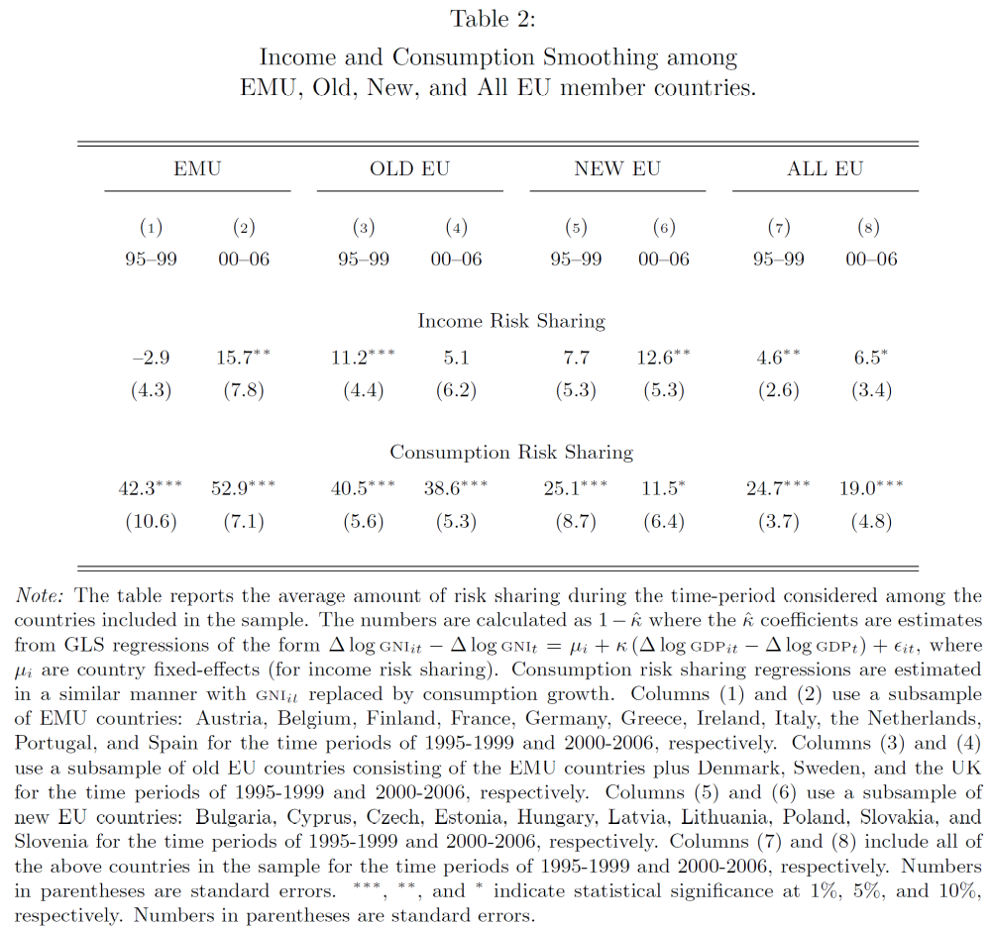
euro area
Results
- More consumption risk sharing than income risk sharing
- Risk sharing has not increased after introduction of euro ← aga miks? 

4. Does higher foreign asset holdings in the EU lead to better income and consumption risk sharing?

Idea → does various measures of country-specific foreign assets relative to foreign assets in “integration area” help explain changes in risk sharing?

A large number of different estimations (with different foreign asset measures) → no clear results

5. Empirical findings: Portfolio holdings

Read yourself!

6. Integration of European banking markets through consolidation and foreign entry

Read yourself!
7. Conclusions

Summary
- Income and consumption risk sharing within the EU and the euro area is generally limited
- Income and consumption risk sharing within the EU and the euro area has not increased after the introduction of the euro
- The reasons for the limited risk sharing are largely unclear!

